Hi Mathieu,

Thank you for sending the first part (coordinates) of the Physocialogical survey and providing clear instructions.

Regarding our upcoming analysis and processing, I have a few questions I hope you can clarify:
- I've reviewed the data and linked it with mrgs_grid_5km_ecwp.shp and mrgs_NW_grid_5km.shp. Many of the records/stations fall outside the mrgs_NW_grids, and some stations are even outside the working regions near the eastern Morocco boundary. Should I include all these records, or prioritize the NW grid stations?
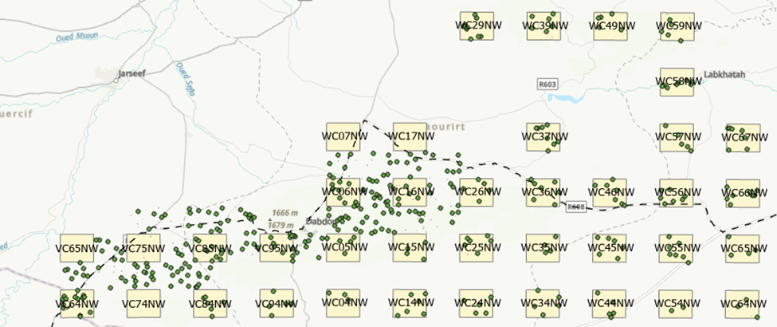
Yes, we’ve performed some habitats inventories outside the study area, particularly during drought years when no fieldwork was possible in the study area. These additional data concern the same biogeographical area and relate to habitats similar to those in the study area. They should be considered as complementary data for the description of habitats. I think you should keep it in your analysis.
Similarly, during years of drought, when the area suitable for inventories was reduced, we sometimes studied all the grids (and not just those in the NW). Keep these data as well.
- The dataset contains 2,246 records/rows with unique coordinates, but many fall into the same 5x5 km grid cell, as marked in the Station_Name column. Generally, you surveyed several times to cover a 25 km2 grid cell, with different Area_M2 values per row (ranging from 0-20,000, most frequently between 1,000-3,000). How did you estimate the area per survey?
Yes, to inventory a grid, we need to perform several habitats relevés, as there are usually many different habitats per grid. Even if there is only one habitat in a grid (which is very rare), we try to carry out at least 3 relevés per grid.
The Area_M2 generally varies from one habitat and relevé to another, as it depends on the complexity of the habitat. In the field, when describing the habitat, we increase this area until we consider that we have found almost all the plant species (no new species observed after walking several other meters), which therefore depends greatly on the site. Also, in the case of small habitats (e.g. a pond), the habitat size can be very small, whereas for large habitats there is no area constraint.
In the field, I note the number of meters walked; Then I multiply this length by 5, which corresponds to the width (in meters) that I consider I can see properly (c. 2,5m to my left and 2,5m to my right).
In terms of Area, can I roughly use the coordinates as central points and the corresponding areas [Yes the coordinates are generally close to the centre of the habitat relevé] to generate square polygons representing the field sample areas [Yes and no, it depends how do you want to create polygons]? I noticed some areas are not square, should they be represented as rectangles or irregular shapes? Would it be acceptable to use square polygons for all field plots for simplicity?
Illustration:
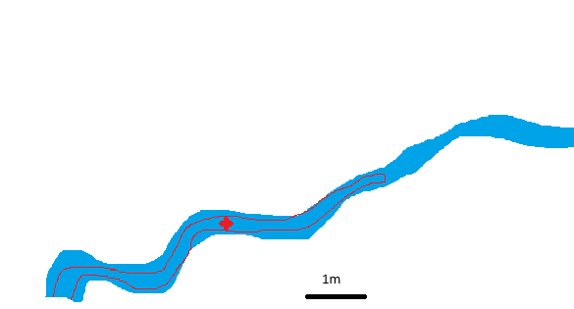
In this wadi, the red star corresponds to the coordinates of the relevé, and the red lines indicate the boundary of the Area_M2. If you generate squares or polygons, they must remain within the wadi. You cannot therefore automatically generate polygons or squares using Area_M2, as this would cause your polygon/square to overlap with other habitats located on the side of the wadi. Unfortunately, each record must therefore be analysed individually, and the squares/polygons must be drawn by consulting the satellite imagery.
Then, for the remote sensing analysis, I plan to retain only areas where Area_M2 > 100, which results in 2,343 records out of 2,445, where Area_M2 = 0, should be anyway removed from next step.
You can also remove the cliffs from your analysis, as for this habitat the Area_M2 is calculated vertically, and this habitat is so narrow (when viewed from above) that it is not really visible on satellite images.
- Regarding habitat types, we currently have 90 unique types, which seems excessive for analysis. From my perspective, reducing this to ~10-15 types would be more manageable. Would it be possible for you to group the habitat types? I don't have the expertise to decide which habitats can be grouped. Could you assist by highlighting habitats most important for Houbara that shouldn't be grouped, or those you are particularly interested in to look at?
Ok, I need to discuss this with my colleagues who are specialists in Houbara. I will keep you informed.

